**Data Visualization Charts**

Segmented Wise Sales, Profit and Quantity

Choosing dashboard

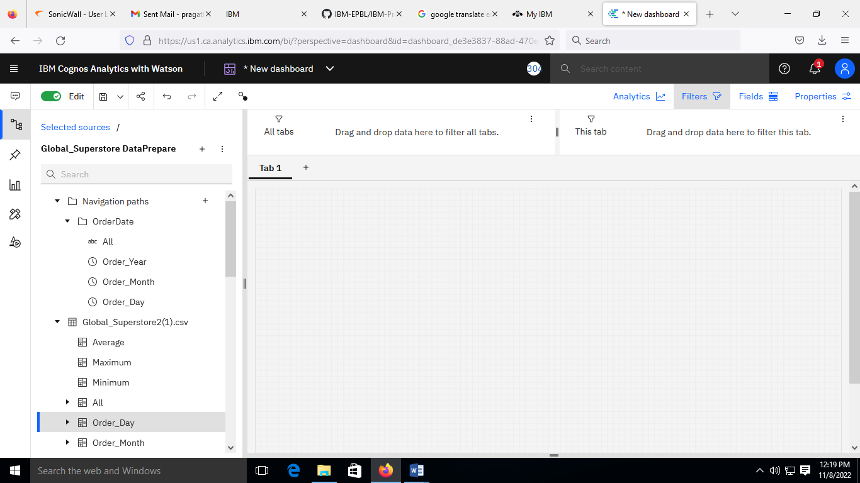

Creating visualization for Sales by Segment

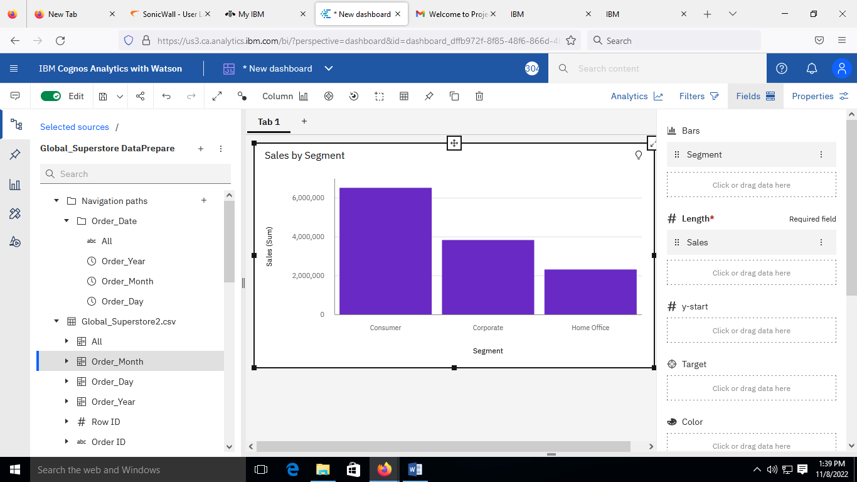

Adding Quantity and profit

